Dixon’s Algorithm for Large Integer Factorization

Jeffrey W. Humphries, Cindy D. Dawson
Department of Computer Science
US Air Force Academy

The quadratic sieve is one of the most basic modern factorization methods. Dixon’s algorithm is a simple form of the quadratic sieve that is easy to understand and fairly easy to implement. While not practical for factorization of “small” numbers, it is instructive to study the algorithm because it serves as the basis for most of the “real world” sieve algorithms that are currently in use. Dixon’s algorithm is based on the following principle:

Suppose there exists an x and y such that 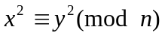. If x is not congruent to 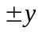, then n is composite. Since

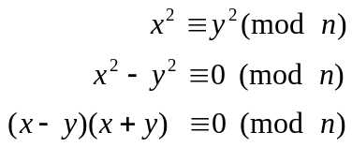

we can obtain a nontrivial factor (a factor other than 1 and n) by calculating gcd(x – y, n).

The goal is to find x and y such that .

Dixon’s algorithm consists of several main steps:
- Generate a factor base
- Generate a set of good equations (using the factor base from Step 1)
- Find solutions by combining the good equations

It may be instructive to work a real example as the algorithm is described. Assume for this example that we are trying to factor the number n = 187 (= 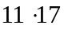).

Step 1 – Generate a factor base

Generate a set consisting of the first t primes 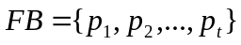; FB is called the factor base. The question of how to choose an appropriate size for the factor base will be addressed later.

For this example, assume we generate a factor base consisting of all primes less than 10:

FB = { 2, 3, 5, 7 }

Step 2 – Generate a set of good equations

We choose numbers, x, at random. We then calculate 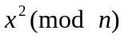. We then try to factor this result using only those primes in the factor base. If the number factors completely, we keep it. If not, we throw it away and try a new random value for x. Generate as many equations as numbers in the factor base.

For our example, suppose the first random value for x is 163. We keep this value because it factors over the factor base:

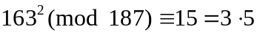

The next random value for x is 102. Since 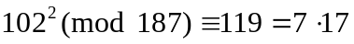, we throw x away (17 is not in our factor base). In this case we would try a new random value for x. We continue in this fashion until we have a set of “good” equations (we need as many equations as we have primes in our factor base):

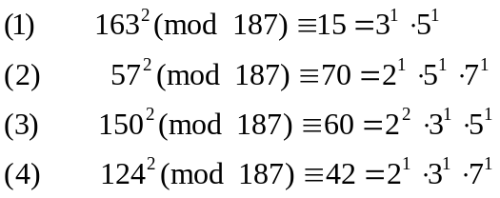

Step 3 – Find solutions by combining the good equations

Our goal now is to combine two or more of the equations to get . Notice that if we multiply equations (1) and (3) together (keeping the left-hand and right-hand sides separate), we get:

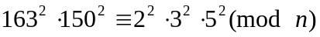

We know the right-hand side is a square since all the exponents are even. Why?

So,

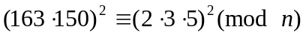 -- note this is in the form

The gcd(x – y, n) = gcd(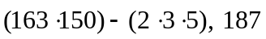) = 11. The algorithm has found a factor!

If we had gotten a gcd = 1 (or n), then we would need to try some other combination of equations. For example, the product of equations (2), (3), and (4) would also generate a square on the right-hand side.

To actually implement this algorithm, we need some way to automate the 3 steps as just described. Step 1, generating the factor base, is trivial to implement. To automate Step 2, the algorithm should continually generate random values for x, calculating and trying to factor this value across all of the primes in the factor base. If it does not factor completely, we toss x and try again. It is helpful during this step if we track the exponents of the factorization of each value in a vector as follows:

2 3 5 7
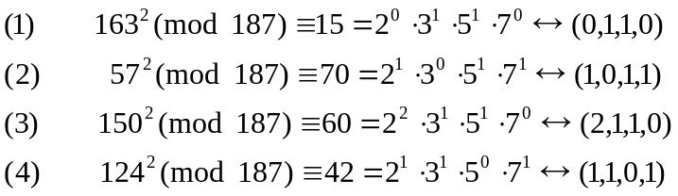

The matrix of vectors then, is:

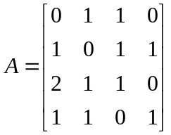

To automate Step 3 (finding solutions by combining the good equations), we need to implement a method to find rows that, when added together, all the exponents are even (and hence we can take a square root). Taking the square root is the same as dividing all of the exponents by 2 (hence the need for even exponents). For example, the square root of 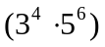 is 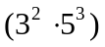.

To find the row combinations that give us what we need, we first reduce the values in the exponent matrix mod 2 (giving us a matrix of all ones and zeroes).

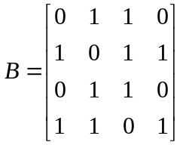

The rows in the matrix correspond to the exponents (reduced mod 2) of the primes in the factorization for each equation, and the columns correspond to the primes in the factor base. Note that a one in this matrix means the original exponent was odd and a zero means that it was even. This helps us determine if we can take square roots.

We can now use a process similar to Gaussian elimination (remember linear algebra?) to generate a matrix that indicates the combination of equations that will give us even exponents in the product.
For example, the result of this process might produce the following matrix:

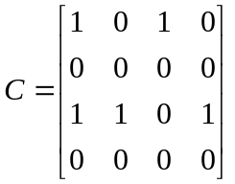

The first row tells us that the 1st and 3rd equations can be multiplied to generate a right-hand side with all even exponents. The third row tells us that we can also multiply the 1st, 2nd, and 4th equations to give us a square on the right-hand side.

We can now have several possibilities that fulfill . We now try to obtain a nontrivial factor (a factor other than 1 and n) by calculating gcd(x – y, n) for each possibility. If we find one, great! If not, the algorithm could be executed repeatedly until a factor is found, though obviously this is quite slow.

What can be done to improve the efficiency of this algorithm? The first question to address is: what size should be chosen for the factor base? Since attempting to factor each value of 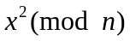takes on the order of t trial divisions (where t is the number of primes in the factor base), obviously the smaller the factor base, the faster we can try to factor. However, a larger factor base makes it easier to factor some numbers and produces more good equations to consider. If the factor base is too large, however, the size of the matrix of exponents makes the work required to find dependencies via Gaussian elimination too great. So, there is a tradeoff between the number of primes in the factor base and the amount of work the algorithm requires to find solutions. Research involving the characteristics of integers near the square root of a number to be factored lead to the following ‘optimal’ approximation for t, the size of the factor base:

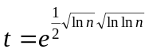

Another efficiency that can be added to Dixon’s algorithm is to generate values for x in the form of 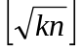, where k = 1, 2, … rather than generate x at random. When squared and reduced mod n, integers in this form are slightly smaller than n. This means that 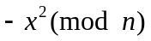 is small and may easily factor over FB. We can therefore include -1 in the factor base to increase the probability of success in finding a good equation.

Alternatively, we can consider those values for x which produce a result just slightly larger than our n to give us the equivalent x² with a small positive value after being reduced by mod n. This guarantees the result will be a product of small primes. Here you can choose your values of x in the form of 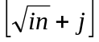 for various values of i, and j is selected to be small. This negates the need to deal with a negative factor in your base.
__________________________
References

Making, Breaking Codes: An Introduction to Cryptology, Garrett, 2001, Prentice-Hall.
Handbook of Applied Cryptography, Menezes, Oorschot, Vanstone, 1996, CRC Press.
Cryptography: Theory and Practice, 2nd Edition, Stinson, 2002, CRC Press. NSA Draft Document 950609
Introduction to Cryptography with Coding Theory, 2nd Edition, Trappe, Washington, 2006, Prentice-Hall.

